IST 331: Human Centered Design

Northland Bowling and Joint Ventures Website Redesign

Tristan Epler, Mark Ranieli, Brenden Kokiko, Mark Walsh

2/10/2023

The purpose of the proposed interface redesign is to create a more user-friendly website that allows customers of the Northland Bowling community to have an interactive website that allows for clear and concise communication of special events. Operations and events included on the website may include birthday parties, bowling leagues/tournaments, bowling times, community outreach, prices, and operation hours. Our group wants to design an interface that allows people of all ages to have a fun and accessible bowling experience at Northland. We also want to incorporate the other aspects of Northland into our interface. Currently Northland has three separate websites for its bowling center, bar, and motel. Our group wants to combine aspects of all three sites under one centralized interface that allows anyone to use any of the three amenities with ease. We want one central location for all information on the three services.

Our expected user group includes high school students, college students, young adults, and parents with children, especially those having birthday parties. Northland offers a wide range of activities for families and people looking to have fun. We want to create an interface that accommodates all ages and to people with any level of technology experience whether they are digital natives or digital immigrants.

For the Problems Found on our Website We Will Apply the Nielson Design Guidelines

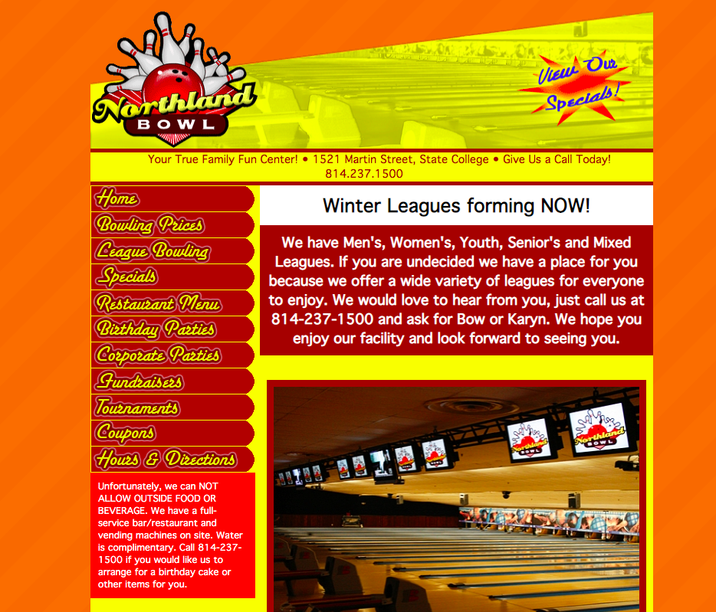

The most obvious problems we found were with the color scheme and the general layout that makes of the website. For the color problem we will be applying the “matching between the system and real world” heuristic by matching the colors and design to the actual bowling alley and by also better highlighting the important information and using colors that make the website easier to understand. Applying the consistency and standards heuristic we also think that I necessary change is matching the fonts and font colors as well as making the font bigger and bolder where it needs to be.

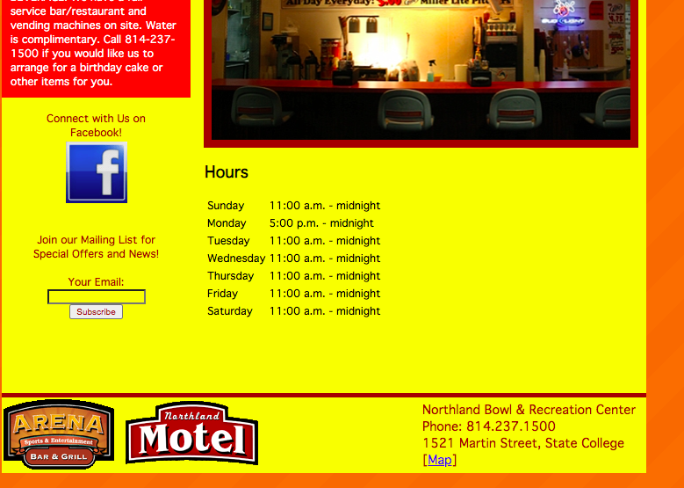

This bowling alley website is also tied to a motel and a restaurant that is connected to the bowling alley and they displayed this by putting links to both websites at the bottom of the page. We would like to change the website design to have a homepage which talks about the 3 locations and featured events, and then have tabs from that homepage which take you to a page which talks about each individual place. For this problem we will be applying the Flexibility and Efficiency of use design combining all into 1 thing and helping the user learn more about the 3 locations. The Facebook link in addition to the email subscription text box also need some revising because both appear unnaturally placed and strange to the user. The heuristic used here would be aesthetic and minimalist design. The email subscription link also takes you to another link which makes you fill in more information and the way those links are structured don’t seem very user friendly as well. The heuristic used for this problem would be user control and freedom since we want to make the text box and connected websites appear more user friendly.

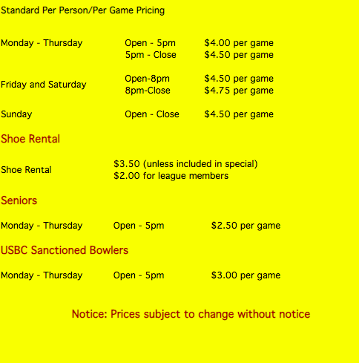

Another problem we found was how when you tab to different parts of the website and if you look at the main page, there are the black words with a yellow background that seem randomly placed and unprofessional. There also doesn’t appear to be much grouping of the words together either. By changing the interface to better display the information and make it look more professional we will be re-using the Aesthetic and minimalist design heuristic.

Establishing a link between Stone’s UI design guidelines, it is clear that the Northland Bowling website’s home page is not the most visually appealing. Visibility of the home page is limited due to the crunching together of many words and lack of optimal spacing. The website’s affordance is a little difficult to understand because the categories on the home page are hard to tell if they are links. Feedback on the website seems doesn’t seem to be an issue if you click on all the links the webpages load successfully and the map at the bottom works if the link is clicked on. The overall simplicity of the website can be worked on so that you can purchase tickets directly online instead of only displaying the prices. The bowling alley website’s structure could be improved by taking on a more simplistic approach instead of an odd layout design.

The website is consistent with the color theme, and the layout across the different webpages. However, when you click on a different webpage within the website the page sizes change and some of the pages are longer or wider than others. Tolerance of the website can be improved by adding the function of routing the user back to the home page if they clicked the wrong tab or button. Accessibility for color blindness would be difficult due to the importance that color plays on this website. The whole website is red and yellow which would make it hard for someone with color blindness to navigate.